Web Design Interface Document

Purpose
The following document describes the web-design interface for the mock up patient information system (PIS). The system is to be design for the database management class at the University of Florida. This system will help the student to understand the complexities and issues that are related to database design.
Since the system will be used be various hospitals and doctors at different physical locations we have decided to use a web based interface as a front-end to the database system. This interface must be simple to used and fully functional for there categories of users. The following is a list of these users.
- Secretaries and Other Authorized Personnel
- Surgeons
- PIS Administrators

Although the system is only a teaching tool the interface and the underlying database system should contain the functionality, security and user-friendly design as a real world application.

Login Page
The initial contact page for the user will be a user login in page. As seen in figure 1. Since the interface will e dealing with patient records and other sensitive data, logging into the system will require two user passwords. From this information, the web-interface
will direct the user to the appropriate initial sub-menu. These menus are as follows
- Secretary Menu
- Surgeon Menu
- PIS Administrator Menu

Figure 1.
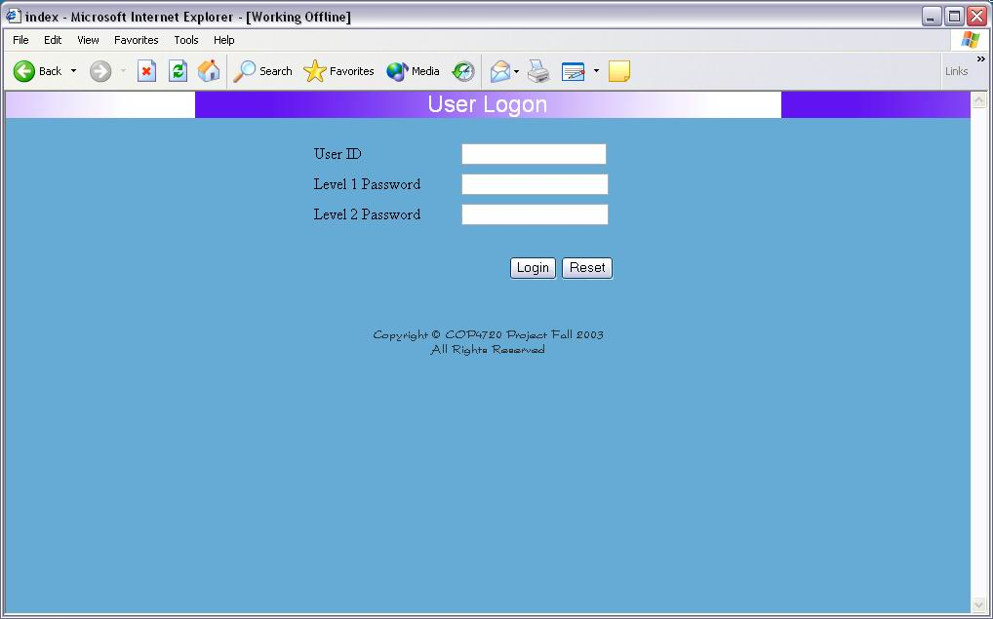

Menu Sub System

Figure 2 is an example of one of the initial sub-menus. Each option will be a hyperlink which directs the user to the appropriate sub-menu. Depending on the status of the user i.e.(Secretary, Surgeon ,Administrator) the option which appear in the menu will be different. In addition each sub-menu will have hyperlinks to the root menu for a given user in order to provide ease of navigation. Figure 2 shows the main menu options for an administrator.

Figure 2.
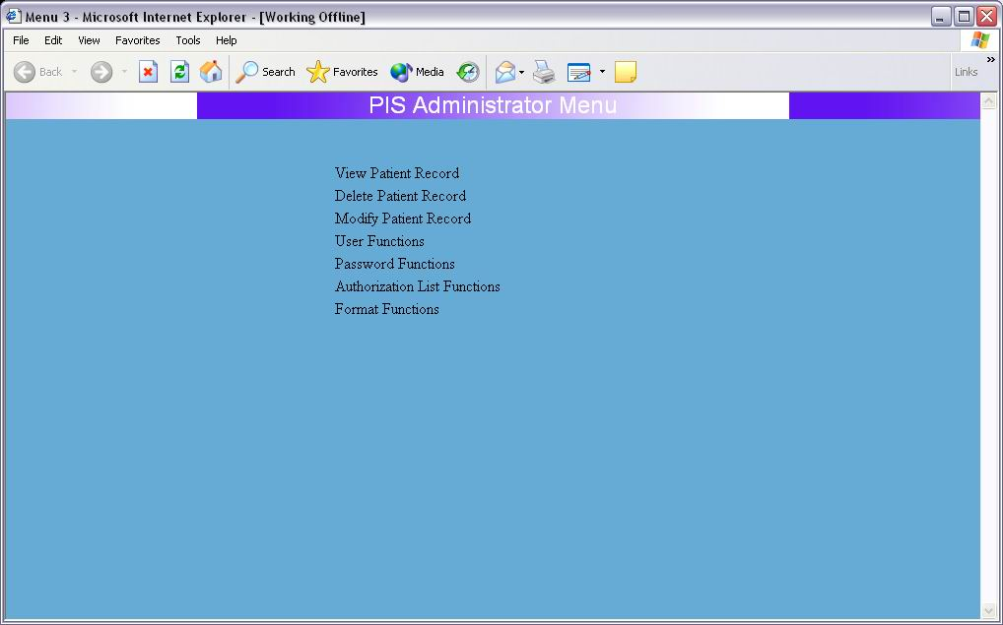

Patient Creation

In this preliminary interface design the add a new patient option is central to all three types of users. For this reason an example interface is shown in figure 3. In order to provide a user-friendly interface, options that are already defined by the database are generated as user menu lists. For example the treating hospital would be a generated pull-down menu list in order to reduced user error, and facilitate user input. Fields such as medical record number, last name, and first name are simple input text boxes.
Once the new patient information is inputted and the add patient button is activated, errors in the medical record number will be checked, as well as inconsistent dates. These errors will then be reported to the user and the appropriate change asked for in order to continue.

Figure 3.
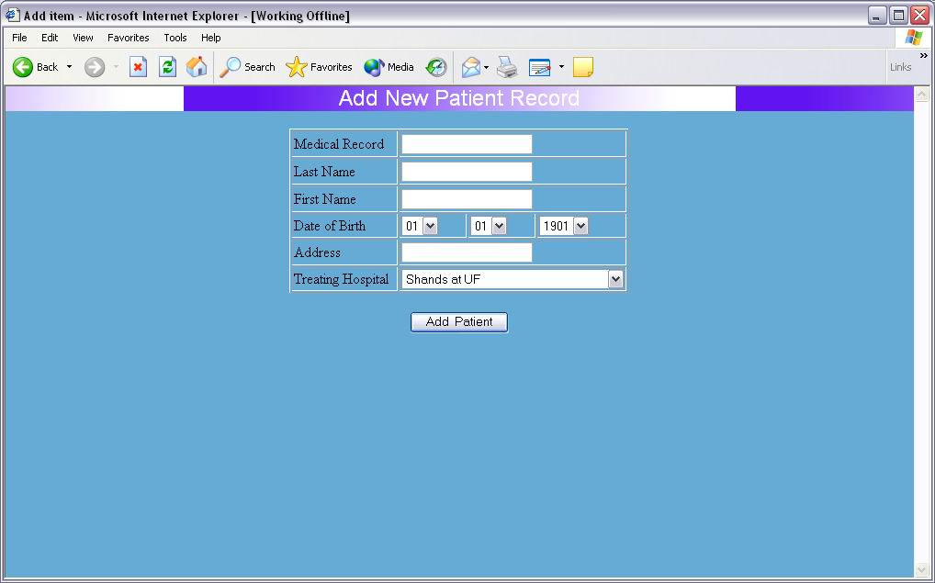

Patient Modification

The system will also need to be able to change information once it has been entered into the database. Modification of a patient record is a two step process. First the record must be found. The interface does this by prompting for a medical record number. Then the user simply activates the find patient button. If the patient record is found the corresponding patient fields are updated and change to the patient information is allowed via the submit button. Note the each field contains the information retrieved from the database in both a non-editable and editable form. Figure 4 shows an example of a typical patient record.

Figure 4.
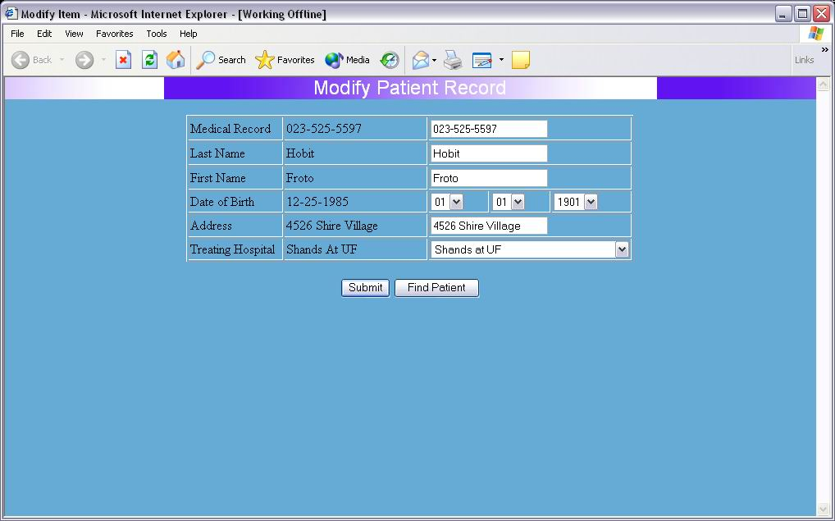

Patient Information View

This option is called from various sub-menus from the various users. Therefore it does not have a search option for the medical record number or other key field. It is presumed that this information will come from a preceding root menu and thus this page will only display information that is found from a previous database search. It is also presumed that the referring pages will do all need error checking. Like Figure 4, Figure 5 shows
a made up database record.

Figure 5.
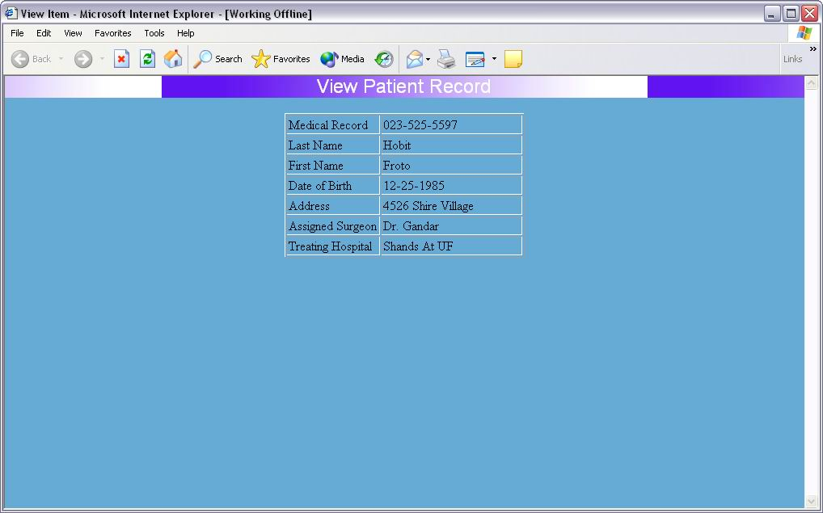

Overall Web Design

The overall design of the website shall be user-friendly, functional and secure. The preliminary design is simplistic in order to facilitate scalability and modifications. Since there will be many users with varying computer backgrounds the web site should not be too complicated the regular user will feel daunted. The following diagram shows the basic structure of the web site.

